
Department of BES-1
DATA STRUCTURES THROUGH PYTHON(24SC1204)
I/IV-B.Tech-(II Sem), Academic Year: 2024-2025

Session-38 (Minimum spanning Tree-Prim’s Algorithm)
Instructional Objective:
- To learn the concept of Minimum Spanning Tree
- To find cost of minimum spanning tree using Prim’s algorithm
Learning Outcomes:
1. Students able to understand the use and applications of minimum spanning tree.
2. Students able to understand Prim’s minimum spanning tree algorithm
Introduction:
A minimum spanning tree (MST) or minimum weight spanning tree is a subset of the edges of a connected, edge-weighted directed or undirected graph that connects all the vertices together, without any cycles and with the minimum possible total edge weight. It is a spanning tree whose sum of edge weights is as small as possible.
Explanation:
Algorithm:
1. Sort all the edges in non-decreasing order of their weight.
2. Pick the smallest edge. Check if it forms a cycle with the spanning tree formed so far. If cycle is not formed, include this edge. Else, discard it.
3. Repeat step#2 until there are (V-1) edges in the spanning tree.
Example: 1
Consider the below input graph.
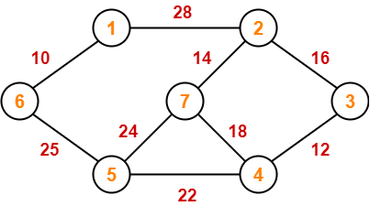

The graph contains 9 vertices and 14 edges. So, the minimum spanning tree formed will have (9 – 1) = 8 edges.
After sorting:
Weight Src Dest
10 6 1
12 4 3
14 2 7
16 2 3
18 5 4
22 8 6
24 5 7
25 6 5
28 1 2

Now pick all edges one by one from sorted list of edges
1. Pick edge 6-1: No cycle is formed, include it.
step 3: Now pick edge 4-12. No cycle is formed, hence include it.

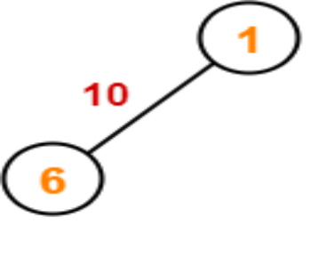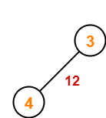

Step 4: Now pick edge 7-2. No cycle is formed, include it.
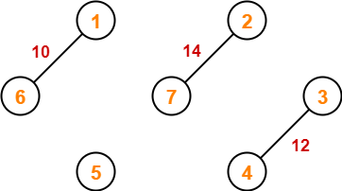
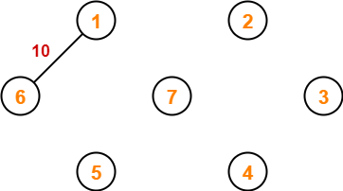

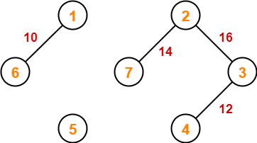
Step 5: Now pick edge 2-3. No cycle is formed, so include it.

Step 6: Now pick edge 5-4. No cycle is formed, so include it.

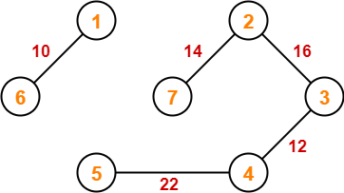

Step 7: Now pick edge 6-5. No cycle is formed, so include it.

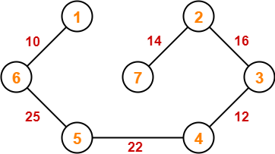

Since all the vertices have been connected / included in the MST, so we stop.
Weight of the MST = Sum of all edge weights
= 10 + 25 + 22 + 12 + 16 + 14
= 99 units

Review questions:
- What is spanning tree?
- What is minimum cost spanning tree?
Summary:
In this session, it was discussed about how to find cost of minimum spanning tree using Prim’s algorithm.

Self-assessment questions:
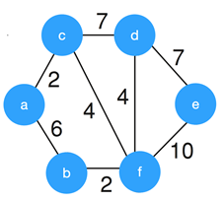
What is the weight of the minimum spanning tree using the Prim’s algorithm?
a) 24
b) 23
c) 15
d) 19
Answer: d

4. What is the time complexity of Prim’s algorithm?
a) O(log V)
b) O(E log V)
c) O(E²)
d) O(V log E)
Answer: b
Terminal questions
CLASSROOM DELIVARY PROBLEMS
- Explain about Prim’s minimum spanning tree algorithm and how it used to find minimum spanning tree using following diagram.
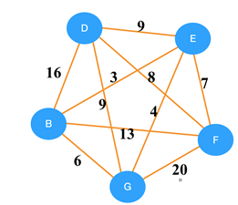

- Analyze the time complexity of Prim’s algorithm.

PRACTICE PROBLEMS
- Using Prim’s algorithm find cost of minimum spanning tree for the following graph.
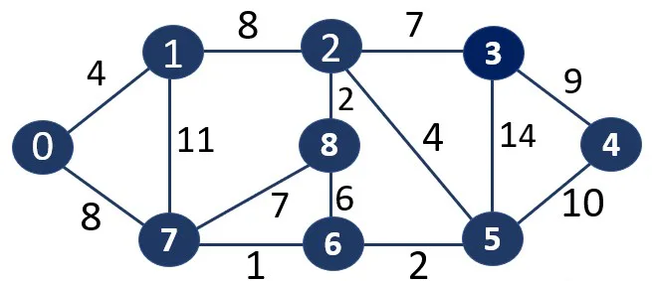

- Find minimum spanning tree for the following weighted graph using Prim’s Algorithm. List out at least four real time applications where Prim’s algorithm is applicable?

- Write an algorithm to implement Prim’s algorithm to find minimum spanning tree of the given undirected graph?

